**CHIROPRACTIC ASSOCIATES CLINIC**

1127 LAKEWOOD COURT NORTH, REGINA, SK S4X 3S3 ∙ PH: (306) 924-5300 ∙ FAX: (306) 924-5252

EMAIL: cac.north@accesscomm.ca

**CHIROPRACTIC INITIAL HEALTH FORM**

**PATIENT INFORMATION**

Last Name: _______________________________ First Name: _______________________________

|  |  |  |
| --- | --- | --- |
| __ __ | __ __ | __ __ |
| MM | DD | YY |

Personal Health #: _ _ _ _ _ _ _ _ _ Date of birth: ☐ Male ☐ Female

Address: ________________________ City: __________ Province: ______ Postal Code: _ _ _ _ _ _

Phone #: Home: ( _ _ _ ) _ _ _ - _ _ _ _ Work: ( _ _ _ ) _ _ _ - _ _ _ _ Cell: ( _ _ _ ) _ _ _ - _ _ _ _

Email: ____________________________________________________________________________

Family Doctor: __________________________ Referring Practitioner: __________________________

Place of Employment: __________________________ Occupation: ___________________________

*NOTE: Text messaging is used to notify patients about upcoming appointments. Would you like to receive text messages from our office?

☐ Yes ☐ No

**EMERGENCY CONTACT INFORMATION**

Emergency Contact Name: ___________________________ Relationship: _____________________

Phone #: Home: ( _ _ _ ) _ _ _ - _ _ _ _ Cell: ( _ _ _ ) _ _ _ - _ _ _ _ Work: ( _ _ _ ) _ _ _ - _ _ _ _

Will you be claiming your Chiropractic treatment under any of the following? Please check the appropriate box.

☐ WCB ☐ SGI ☐ RCMP ☐ DVA ☐CAF

☐ Supplementary Services (Government Program)

(Senior Income Plan, Family Income Plan and Social Services)

Claim #: _____________ Contact Person: _________________ Phone Number: ( _ _ _ ) _ _ _ - _ _ _ _

Have you seen a Chiropractor before? ☐ Yes ☐ No

If so, who? _______________________ For what complaint? __________________________

Have you had any imaging on the area of concern? ☐ X-ray ☐ MRI

☐ CT Scan ☐ULTRA SOUND

When? _____________________ Where were the images taken? ______________________

1/4

**PAST AND PRESENT MEDICAL INFORMATION**

Please **circle** any conditions that **presently** cause you problems.

Please **check** any conditions that were a problem for you in the **past**.

|  |  |  |  |
| --- | --- | --- | --- |
| **General Symptoms:**  Headache  Fever  Sweats  Fainting  Dizziness  Convulsions  Nervousness  Loss of weight  Numbness, pain, tingling | **Genitourinary:**  Poor appetite  Blood in urine  Kidney Infection  Bed wetting  Prostate trouble (men) | **Respiratory:**  Chronic cough  Spitting up phlegm  Spitting up blood  Chest pain  Difficulty breathing | **Have you recently had:**  Recent fever/infection  Unexpected weight loss  Pain waking you up at night  Night sweats  Bowel or bladder problems  Numbness or tingling  History of cancer |
| **Muscles and Joints**:  Stiff neck  Backache  Swollen joints  Painful tailbone  Foot trouble  Shoulder pain  Elbow pain  Wrist pain  Hand pain  Hip pain  Knee pain  Arthritis  Have you had any fractures?  _____________________ | **Cardiovascular:**  Pain over heart  Stroke  Hardening of Arteries  High blood pressure  Varicose veins  Swelling of ankles  Poor circulation  Angina | **G.U. for Women:**  Painful menstruation  Excessive flow  Cramps or backache  Vaginal discharge  Swollen breasts  Lumps in breasts  Hot flashes  Number of pregnancies:  ___________________  Number of children:  ___________________ | **Do you currently have any of the following symptoms:**  Dizziness  Trouble swallowing  Trouble speaking  Fainting  Double vision  Unusual balance issues  Nausea  Numbness |
| **Gastrointestinal:**  Poor appetite  Indigestion  Excessive hunger  Belching (gas)  Nausea/vomiting  Vomiting with blood  Pain over stomach  Constipation  Diarrhea  Hemorrhoids  Jaundice  Gall bladder problems  Ulcer  **Please list any medications you are currently taking:**  2/4 | **Eyes, Ears, Nose, Throat:**  Failing vision  Crossed eyes  Eye pain  Deafness  Earache  Asthma  Frequency colds  Sinus infections  Enlarged glands  Enlarged thyroid | **Skin:**  Rashes  Itching  Bruises easily  Dryness  Boils | **Please list past/recent surgical procedures:**  _______________________  _______________________  _______________________  _______________________  _______________________ |

**REASON FOR VISIT**

What brings you into the office today? ___________________________________________________

When did this complaint begin? ________________________________________________________

How often does this complaint bother you? _______________ How long does it last? _____________

Is there ever a time when the pain does not bother you? _____________________________________

How would you describe the pain? (Ex: Sharp, stabbing, achy, dull). ____________________________

Do you have any numbness or tingling in the arms or legs? ___________________________________

Does your pain radiate down the leg or arm? ______________________________________________

Is there anything you find relieving (ex: ice, heat, rest)? ______________________________________

Is there anything you find aggravating (ex: standing, bending over)? ____________________________

Have you received treatment/surgery for your current complaint? If so, from whom?

Has there been a change in bowel/bladder function? ☐ No ☐ Yes Describe: ______________________

If the complaint is related to your back, is the pain mainly in the back or leg?

☐ Back Dominant.

☐ Leg Dominant.

Do you have a history of back problems? ________________________________________________

Do you have, or have you ever had, any medical conditions? (Ex: high blood pressure, high cholesterol, diabetes, cancer, heart attack, stroke, or any other medical condition or event). Please list.

__________________________________________________________________________________

Please list any past or present medical conditions that your blood-related family members are affected by.

(Ex: high blood pressure, high cholesterol, diabetes, cancer, heart attack, stroke, or any other medical condition or event). Please list.

__________________________________________________________________________________

Do you have any allergies? If so, please list. ______________________________________________

Have you had any falls, motor vehicle accidents, or other traumatic incidents?

__________________________________________________________________________________

What is your height? ________________________ What is your weight? ________________________

3/4

**PAIN QUESTIONNAIRES**

**Body Pain Diagram**

Please fill this out carefully. Use the appropriate symbols (provided below) to mark the area on the diagram where you feel the described sensation. Include all affected areas, including radiation of pain.

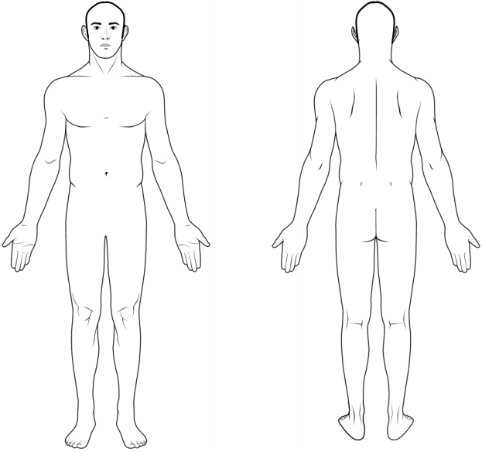

|  |  |
| --- | --- |
| Numbness | = = = |
| Burning Pain | x x x |
| Aching Pain | ( ( ( |
| Pins & Needles | o o o |
| Stabbing Pain | / / / |

**Level of Disability**

What is the overall level of disability? (Please check the most appropriate response).

☐ No Limitations.

☐ Mild Limitations – able to do most activities with minor modifications.

☐ Moderate Limitations – able to do most activities with modifications.

☐ Severe Limitations – unable to perform most activities.

**Visual Analog Scale**

If you had to rate your pain on a scale of 0 - 10, (0 = no pain, 10 = most pain imaginable), where would you rate your pain right now? Please indicate on this scale with a check or circle.

__________________________________________________________________________________

0 1 2 3 4 5 6 7 8 9 10

*Chiropractic Associates Clinic is a multi-disciplinary clinic. If at any time you see more than one health care practitioner at this clinic, presently or in the future, do you agree to allow your health care practitioners to communicate with each other about your case?* ☐ Yes ☐ No

*If the need should arise, do you agree to allow your health care practitioners to communicate with other members of your health care team outside of this office? (i.e. General Practitioner, other specialists, etc…)*  ☐ Yes ☐ No

*I hereby certify that the above information given are true and correct as to the best of my knowledge.*

____________________________________ _______________________________

**Patient Signature/Legal Guardian Date**

4/4

**CHIROPRACTIC ASSOCIATES CLINIC**

1127 LAKEWOOD COURT NORTH, REGINA, SK S4X 3S3 ∙ PH: (306) 924-5300 ∙ FAX: (306) 924-5252

EMAIL: cac.north@accesscomm.ca

Macintosh HD:Users:erinogrady:Desktop:NEW Chiro Informed Consent.pdf

