CHIROPRACTIC ASSOCIATES CLINIC
SGI MOTOR VEHICLE ACCIDENT QUESTIONAIRE
__ __ | __ __ | __ __
MM | DD | YY
Patient’s Name: ________________________________________ Date:
__ __ | __ __ | __ __
MM | DD | YY
SGI Claim #: ___________ Date of Accident:
Adjuster: _______________________________
Where did the accident occur? ___________________________________________________________
Were you driving at the time of the accident? ☐ Yes ☐ No
What kind of vehicle do you drive? _______________________________________________________
What kind of vehicle struck you/did you strike? _____________________________________________
Upon impact, your car was: ☐ Stopped ☐ Moving ☐ Turning right ☐ Turning left
Where was the damage on your vehicle? ☐ Left front ☐ Right front
☐ Left side ☐ Right side
☐ Left rear ☐ Right rear
What was the estimated speed of impact? _________________________________________________
Did you see the accident coming? ☐ Yes ☐ No
Did you have a seat belt on? ☐ Yes ☐ No
Upon impact, which way were your thrown? _______________________________________________
Upon impact, what did you experience? ___________________________________________________
When did you first experience your symptoms? _____________________________________________
Were you able to get out of the vehicle and walk? ___________________________________________
Were you conscious at all times? ☐ Yes ☐ No
Could you move all parts of your body? ☐ Yes ☐ No
__ __ | __ __ | __ __
MM | DD | YY
Was an ambulance called for you? ☐ Yes ☐ No
Did you go to the Hospital, or to a clinic? ☐ Yes ☐ No Date:
If so, place: ________________ Attending Physician:______________________
Was there any imaging done? ☐ X-ray ☐ MRI ☐ CT Scan
If so, at what location? __________________________________________________________
Was there any medication prescribed? ☐ Yes ☐ No
If so, what was prescribed? ______________________________________________________
Have you consulted another physician? ☐ Yes ☐ No
If so, Physician name: ___________________________________________________________
Were you able to sleep that night? ☐ Yes ☐ No
What symptoms have you experienced as a result of the accident? _____________________________
___________________________________________________________________________________
Did you take time off work? ☐ Yes ☐ No
If so, what dates have you taken off? _______________________________________________
Are you able to perform your work duties? ☐ Yes ☐ No
If no, please describe what you are having difficulty with: _______________________________
_____________________________________________________________________________
Are you able to perform your activities of daily living? ☐ Yes ☐ No
If no, please describe what you are having difficulty with: _______________________________
_____________________________________________________________________________
List any prior motor vehicle accidents, and the date(s) they occurred: ____________________________
___________________________________________________________________________________
Describe any pre-existing or unrelated conditions: ___________________________________________
___________________________________________________________________________________

PAIN QUESTIONNAIRES

Body Pain Diagram

Please fill this out carefully. Use the appropriate symbols (provided below) to mark the area on the diagram where you feel the described sensation. Include all affected areas, including radiation of pain.
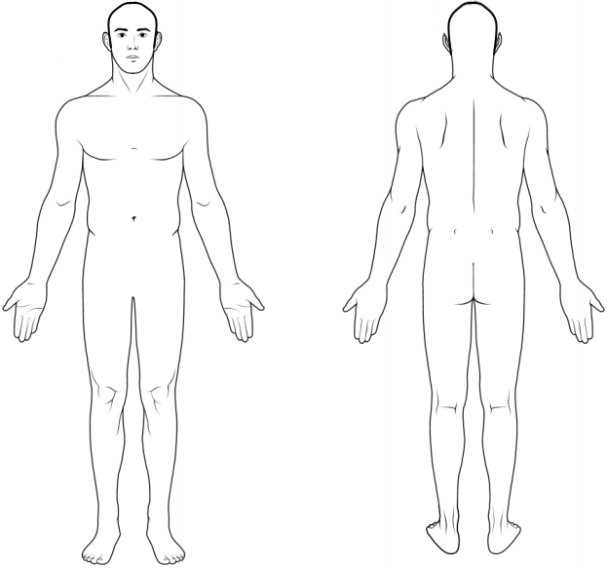

Numbness | = = =
Burning Pain | x x x
Aching Pain | ( ( (
Pins & Needles | o o o
Stabbing Pain | / / /

Visual Analog Scale

If you had to rate your pain on a scale of 0 - 10, (0 = no pain, 10 = most pain imaginable), where would you rate your pain right now? Please indicate on this scale with a check or circle.

__________________________________________________________________________________

0 1 2 3 4 5 6 7 8 9 10

__________________________________ _________________________________________
Date Signature

