CHIROPRACTIC ASSOCIATES CLINIC
W.C.B. ACCIDENT REPORT CLAIM FORM
Patient’s Name: ________________________________________________ Date: __ __ / __ __ / __ __
M M D D Y Y
Date of accident: __ __ / __ __ / __ __ Time of accident: __ __ : __ __ AM / PM
M M D D Y Y
WCB Claim ________________________ Were WCB forms filled out by your employer? ☐ Yes ☐ No
Adjuster: ___________________________________ Adjuster’s Phone Number: ( _ _ _ ) _ _ _ - _ _ _ _
Name of employer: ___________________________________ Employer Phone: ( _ _ _ ) _ _ _ - _ _ _ _
Employer Address: ____________________________________________________________________
Location where you were when the accident occurred? _______________________________________
What were the circumstances leading up to the accident? _____________________________________
___________________________________________________________________________________
Describe the injury. ___________________________________________________________________
___________________________________________________________________________________
Were there witnesses? ☐ Yes ☐ No
If yes, who? ___________________________________________________________________
What did you do immediately after the accident? ____________________________________________
Have you ever had a WCB claim before? ☐ Yes ☐ No
If yes, what was the injury? Was it for a similar complaint? _______________________________
_____________________________________________________________________________
Have you lost any time at work since this accident? ☐ Yes ☐ No
If so, what dates have you missed? _________________________________________________
Have you seen another health care provider in regards to this accident? ☐ Yes ☐ No
If yes, who did you see and what treatment/advice was given? ____________________________
_____________________________________________________________________________

Is there a previous condition that might have a bearing on this injury? ☐ Yes ☐ No
If yes, please describe: ___________________________________________________________
Are you able to work at your full capacity now? ☐ Yes ☐ No
If not, what limitations are you experiencing? _________________________________________
_____________________________________________________________________________
Are you able to all of your activities of daily living? ☐ Yes ☐ No
If not, what limitations are you experiencing? _________________________________________
_____________________________________________________________________________

PAIN QUESTIONNAIRES

Body Pain Diagram

Please fill this out carefully. Use the appropriate symbols (provided below) to mark the area on the diagram where you feel the described sensation. Include all affected areas, including radiation of pain.
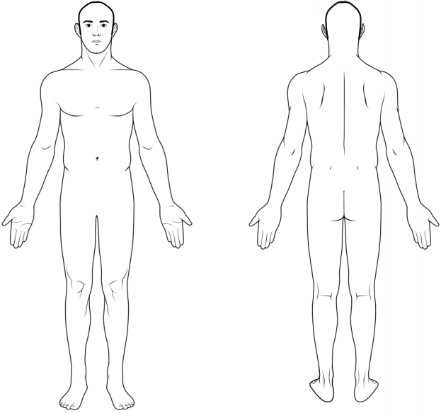

Numbness | = = =
Burning Pain | x x x
Aching Pain | ( ( (
Pins & Needles | o o o
Stabbing Pain | / / /

Visual Analog Scale

If you had to rate your pain on a scale of 0 - 10, (0 = no pain, 10 = most pain imaginable), where would you rate your pain right now? Please indicate on this scale with a check or circle.

__________________________________________________________________________________

0 1 2 3 4 5 6 7 8 9 10

__________________________________ _________________________________________
Date Signature

