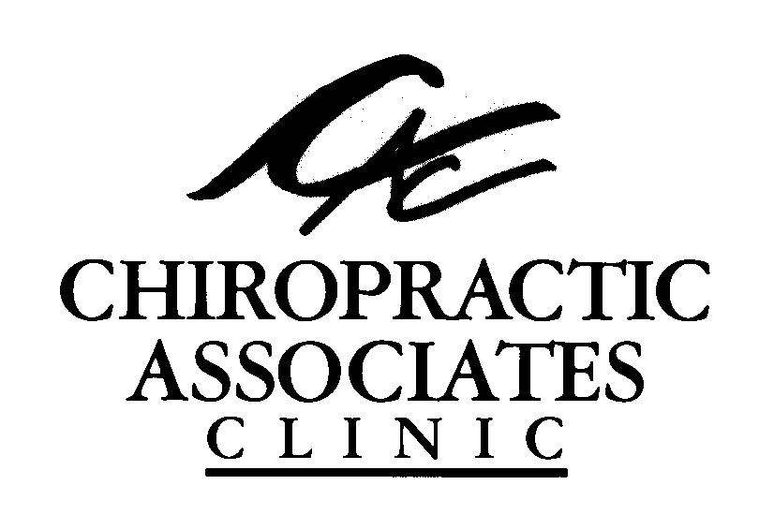
CHIROPRACTIC ASSOCIATES CLINIC

1127 LAKEWOOD COURT NORTH, REGINA, SK S4X 3S3
PH: (306) 924-5300 FAX: (306) 924-5252 EMAIL: cac.north@accesscomm.ca

The QuickDASH

Name: ______________________ Claim Number: ____________ Date:
__ __ | __ __ | __ __
MM | DD | YY

Which Chiropractor are you visiting today? ☐ Dr. Donbrook ☐ Dr. Pattison

1/3

2/3

Signature: _______________________________ Date: _______________________

3/3

